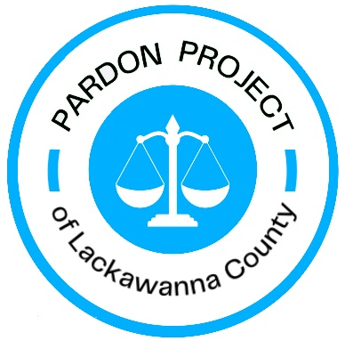
Find us on Facebook: @PardonProjectofLackawannaCounty
IMPORTANT WEBSITES FOR PARDON COACHES
www.votespa.com – REGISTER TO VOTE – people with criminal records CAN vote in PA!!!
https://ujsportal.pacourts.us/CaseSearch – PUBLIC criminal records [NOT everything!]
SEARCH BY: “PARTICIPANT NAME”
Enter LAST name, FIRST name, and
On DOCKET TYPE, click “CRIMINAL”
Because of “Clean Slate,” what you see will NOT include arrests that did not result in convictions, and MAY not include all convictions for lower-level misdemeanors. Try to get the full “secure court summary” from the court. You will need an authorization form signed by the client.
bop.pa.gov – Board of Pardons website
For application form and instructions
Under APPLY FOR CLEMENCY select HOW TO OBTAIN AN APPLICATION
It has the forms AND instructions
plsephilly.org/pardon-video-library/
-- short instructional and peer-to-peer videos about applying for a pardon – share with clients
plsephilly.org/pardon-coach-toolkit
Password is: people-change! [case sensitive]

2P&P letter and data request September 2020 – Philadelphia Lawyers for Social Equity (plsephilly.org)
-- questions asked by the Department of Probation and Parole of every pardon applicant
Latest News from PLSE – Philadelphia Lawyers for Social Equity (plsephilly.org)
– sign up here for our monthly newsletter to receive helpful hints and updates

QUESTIONS?
Email: Phone:

